2 Minute Form
Trip Name: Lake Arapuni - Dawn parade – Waikato River
Check-in Name and Phone: Ian Henderson at 078832703
Date: Branch: North Shore
Leaders
Cell Phone Number
VHF Call Sign &/or Vessel Name
Vehicle make, model, registration, colour
General Plan
Note: If plan changes, you must notify your Check-in person.
Latest Time Off the Water |  |  |  |  | TMP used²⁰
Tide/ Forecast Lake Level | Low n/a |  |  | High
Communications Carried²¹ | VHF, Cell Phone, PLB
Communications | We will be communicating as a group on VHF Channel 06_____
Equipment Carried
Trip Report
(Use other side if more space required)

Activity | Kayaking – Arapuni – Dawn Parade | Centre | North Shore | Location – Waikato River |  |  |  |  | Difficulty¹ |  |  | Strong beginners
Activity Description | “Arapuni Dawn” – start the day at 6am, have your own spiritual experience watching the river wake up (6km). Always enchanting! Huge cliffs, gorgeous reflections. Paddle and drift to dam and back. Then after a late breakfast, options include riverside walk to swing bridge and café (3 hrs.) or cycle on Waikato River Trail. |  |  |  | Leader qualification req.² |  | Sea Kayak Leader
Get in Location | Jones Landing |  |  |  | Map no.⁴ |  |  |  | Distance |  |  | 6km
Get out Location | Jones Landing. |  |  |  | Coastguard Channel |  | 16 |  | Nowcasting |  |  | 22, 23
Emergency get out ⁵ | Along river bank |  |  |  | Emergency / Coastguard Station |  |  |  | Phone
 |  |  |  |  | Drinking Water⁶ | River |  | Toilets⁷ |  |  | at Jones Landing
Emergency Response | Refer Emergency Response Booklet |  |  |  |  |  |  | Parking⁸ |  |  | Jones Landing
Specific Equipment Required⁹ |  |  |  |  | Working Communications equipment in this area¹⁰ | Cellphone - unreliable |  |  |  |  |  |  | PLB  VHF Sat Phone
Other resources  and notes¹¹ | Gate to Jones Landing may be locked between 8pm and 6am.  Cellphone coverage in gorges is unreliable – may need to climb a hill, and then need to ring a landline. |  |  |  | Weather Parameters¹² | 15knot or less head wind
Previous incidents¹³

Safety Management¹⁴
Hazard |  | Significant?  - E/I/M |  | Management Strategy¹⁵ |  |  |  | Hazard | Significant?  - E/I/M | Management Strategy¹⁵
Cold Water |  | Yes - M |  | Carry spare dry clothes and shelter |  |  |  | Deep Water | Yes - E | Correctly fit PFDs
Medical Conditions |  | Yes - M |  | - Leader has first aid qualification  - Ask customers about medical conditions |  |  |  | Bad Weather | Yes - M | Understand weather forecasts.  Have back up plans or pull out if necessary
Capsizing |  | Yes - M |  | - Correctly fit PFDs  - Skills at performing rescues. |  |  |  | Heat / Sun | no - M | - Protective Clothing (worn), Sunglasses, Hat  - Sun Screen  - Plenty of drinks
Panic |  | Yes - M |  | Ensure conditions match level  of skills |  |  |  | Obstacles | Yes - M
Hunters |  | Yes - M |  | Avoid the first w/e of May as it is the opening of duck shooting season. |  |  |  | Other Vessels | Yes - M | - Understand the “rules of the sea”  - “Be seen” – Have two of the following; flag, brightly coloured kayak, brightly coloured Pfd or hat. At night: an all- round white light & a powerful torch.
Other Hazards |  |  |  |  |  |  |  | Power Boats | Yes - M | Power boats, water skiers, wake-boarders if paddled after 9am
Written up by: | Ruth E. Henderson |  | Approved By: |  | James Fitness | Signed: | 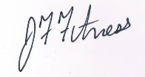 |  | Date: | 14/08/14 | Review in: | 12 months from date of approval

Additional Information Sheet (Optional)
Introduction (A general introduction)
Description (A description of the tour – as if you were selling the idea to someone)
Local Attractions |  | Transport/ Local Operators
 | Contact details |  | Contact details
Local Eateries
 | Contact details
Accommodation/ Campsite Locations |  |  | Facilities
Name | Camping at private property (Private home with camping in adjoining field. Use of house facilities inc hot showers).  Or freedom camping at Jones Landing (shade trees, flush toilets only) |  |  |  | Fuel | no
Phone |  |  | Showers | no | Power | no
E-mail |  |  | Toilets | yes | Water Access | yes
Website |  |  | Laundry | no | Pool | no
Physical Address |  |  | Water | river | Fires Allowed | Yes in winter
Other |  |  | Supplies | no
Other information

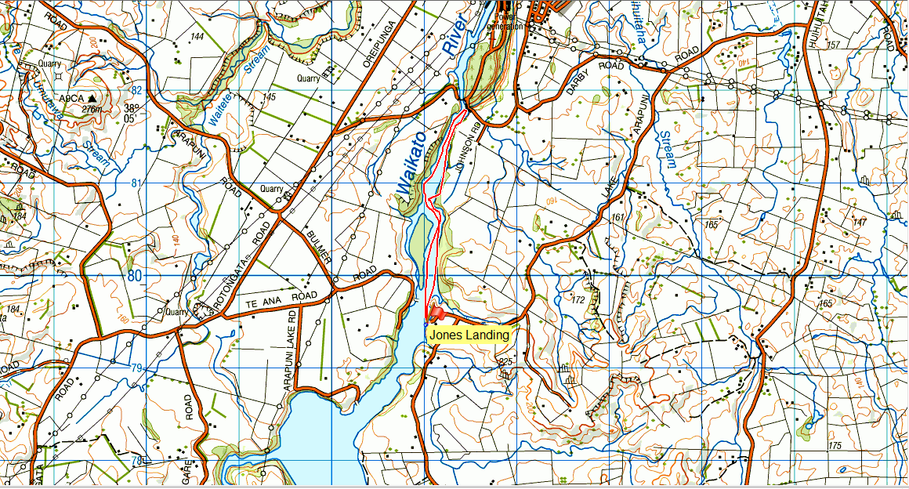

Activity Equipment Check list
Equipment List
- Helmet (rivers & surf) Group Gear
❑ Beanie / hat  Split paddles
❑ Thermals  Repair kit
❑ Paddle Jacket  Fire lighting
❑ PFD  Cooker/thermos
❑ Spray deck  Spare thermals
❑ Booties  Tow system
❑ Water & food  1st Aid Kit
❑ Kayak & paddle  Flares
Group - Oceans & Lakes  Compass
❑ Pumps & Paddle Floats  Charts / Maps
Group - River  GPS (optional)
❑ Throw ropes  Knife (cut rope)
❑ Pin kit & saw  Emergency Shelter

In case of emergency: Dial 111, Mayday :VHF Channel 16

Kayaking Check list

❑ Trip plan
❑ Latest weather forecast
❑ Conditions match skills?
❑ Hyperthermia (hot) &
Hypothermia (cold)
❑ On & off water safety
❑ Environmental concerns
❑ Emergency Procedures include emergency get out.
❑ Working communication devices
e.g. VHF radio, mobile phones, PLB
❑ Specific safety issues for this trip
❑ Participant list
❑ Any medical conditions
❑ All participants keen to proceed?

❑ Trip Plan/ 2-minute form lodged with Ops. Manager

Appropriate wind conditions to run trips:
Novice - no significant surf or swell, wind under 15knots
Intermediate- surf or ocean swells less than 1.5 meter or wind under 25 knots.
Advanced- any condition that is suitable to the trips aims

At conclusion of trip:
Contact check in person
Group Debrief.

Check in Person Ph:
__________________ Mobile
__________________ Work
__________________ Home

Activity Document Cover Sheet

Activity:
Date of Activity:

Activity reports. Is all relevant information present:
– Approved Trip Management Plan (TMP)/ 2 minute form
– Club Trip Participant Sheet
– Weather forecast
– Activity Check List
– Trip report (May be on the 2 minute form)
– Accident / incident reports
Leaders Signature:
Date:

